**NAME: WAJIHA M. ISMAIL**

**STUDENT ID: CSC-18F-073**

**SECTION: 1A**

**SUBJECT: INTRODUCTION TO COMPUTING**

**TEACHER: MS. SAMREEN JAVED**

**TASK # 03**

Q.Write at least 20 short cut keys and demonstrate on a paragraph that how you apply.

|  |  |  |  |
| --- | --- | --- | --- |
| **S. NO** | **SHORTCUT KEY** | **USE FOR** | **HOW TO USE** |
| 1 | CTRL+C | (COPY) | It is used to copy any selected text or file. |
| 2 | CTRL+V | (PASTE) | It is used to paste any copied text or file from clipboard. |
| 3 | CTRL+X | (CUT) | It is used to cut any selected text or file. |
| 4 | CTRL+Z | (UNDO) | It is used to undo any changes made before. |
| 5 | CTRL+Y | (REDO) | It is used to redo any changes made by undo (CTRL+Z) function. |
| 6 | CTRL+A | (SELECT ALL) | It is used to select all text in a file or all files & folders in a specific folder where ctrl+a is applied. |
| 7 | CTRL+N | (NEW DOCUMENT) | It is used to create and open a new untitled document in any program. |
| 8 | CTRL+W | (CLOSE CURRENT DOCUMENT) | It is used to close any document window in any program you are working and is also used to close a tab in chrome browser and it is also used in closing a window in file explorer. |
| 9 | CTRL+O | (OPEN FILE) | It is used to open an existing file from the directory. |
| 10 | CTRL+B | (BOLD TEXT) | It is used to bold the selected text. |
| 11 | CTRL+I | (ITALIC TEXT) | It is used to italicize the selected text. |
| 12 | CTRL+S | (SAVE DOCUMENT) | It is used to save the current document in which we are working. |
| 13 | CTRL+U | (UNDERLINE TEXT) | It is used to underline the selected text. |
| 14 | ALT+F4 | (CLOSE PROGRAM) | It is used to close any program in which we are working. It is also used in closing Windows System. |
| 15 | ALT+TAB | (SWITCH PROGRAMS) | It is used to switch between opened programs in your taskbar. |
| 16 | F2 | (RENAME) | It is used to rename any selected file. |
| 17 | F5 | (REFRESH) | It is used to refresh any window of the program. |
| 18 | HOME | (BEGINNING) | It is used to go to beginning of current line. |
| 19 | End | (END) | It is used to go to end of current line. |
| 20 | CTRL+HOME | (BEGINNING OF DOCUMENT) | It is used to go to beginning of the current document. |
| 21 | CTRL+END | (END OF DOCUMENT) | It is used to go to the end of the current document. |
| 22 | F1 | (HELP) | It is the universal help in almost every Windows program. |
| 23 | ALT+E | (EDIT OPTIONS) | It is used to edit options in current program. |
| 24 | ALT+F | (FILE MENU OPTIONS) | It is used to get file menu options in the current program. |
| 25 | CTRL+F | (FIND) | It is used to Open find window for current document or window. |
| 26 | CTRL+P | (PRINT) | It is used to print the current page or document. |

**TASK # 04**

Q. Practice and label 10 tools each from Insert Tab and Design Tab, Also practice page setup.

**INSERT TAB**

**Cover Page:** It is used to add cover in any document for example we want to make a book we can add cover to it by this tab



**Table:** It is used to create a simple table to place data into it.

|  |  |  |
| --- | --- | --- |
| **SNO** | **NAME** | **ID** |
|  |  |  |
|  |  |  |
|  |  |  |

**Pictures:** It is used to insert any type of image in the document.



**Shapes:** It is used to insert shapes

**Smart Art:** It is used to add shapes specially designed for presentations that describe some type of business cycles or processes etc.

**CHART:** It is used to create chart with the help of MS EXCEL data columns

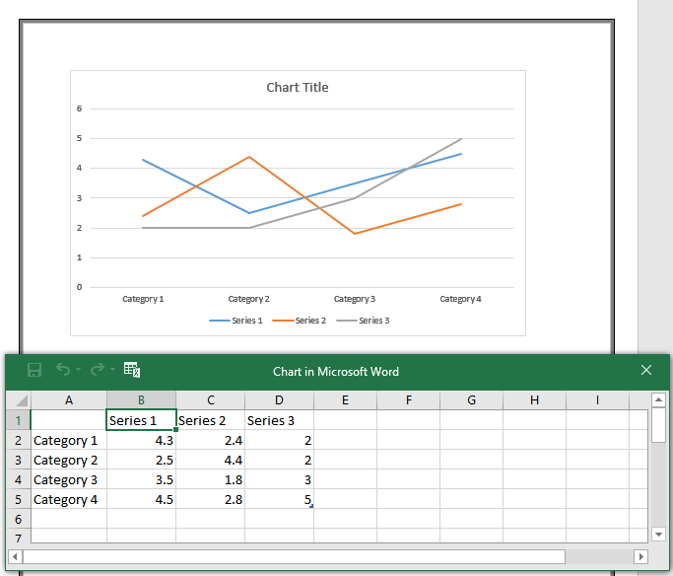

**HEADER & FOOTER:** Header means (title, date etc.) at the top of the page and Footer means something like (text, page no. etc.) at the bottom of the page

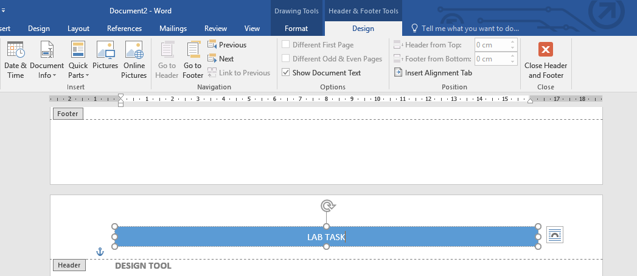

**DESIGN TOOL**

**WATERMARK:** It is used to implement watermark

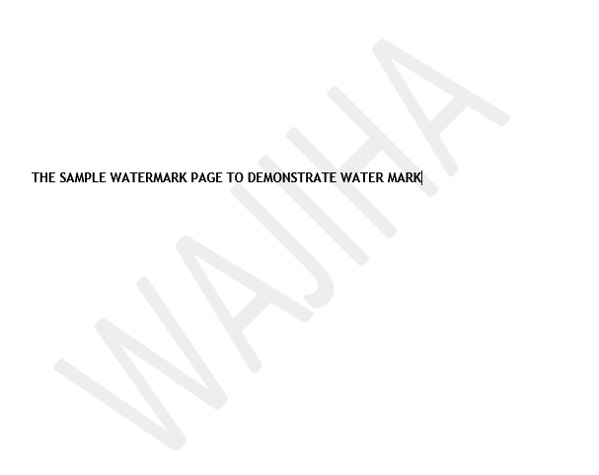

**PAGE COLOR**

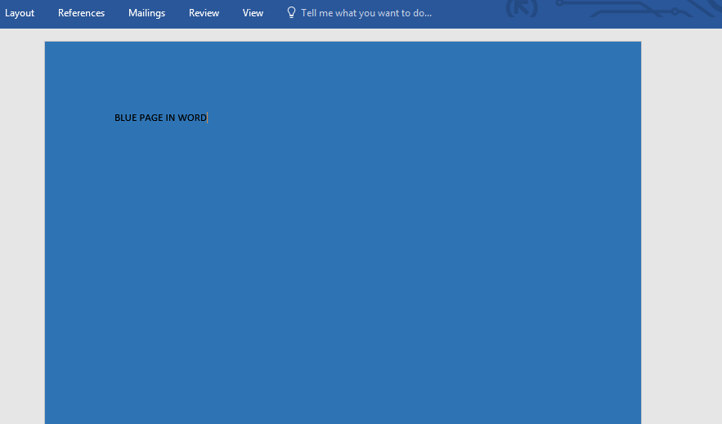

**PAGE BORDERS**

